Types of Internal Rhyme
# Source: Chatgpt (GPT-4-turbo) at [8/2/2025]
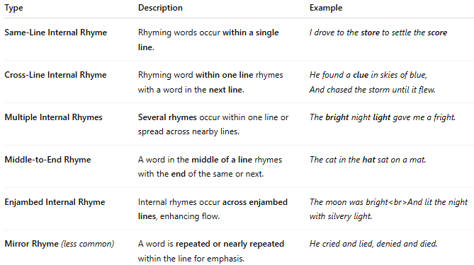

Type | Description | Example
Same-Line Internal Rhyme | Rhyming words occur within a single line. | I drove to the store to settle the score
Cross-Line Internal Rhyme | Rhyming word within one line rhymes with a word in the next line. | He found a clue in skies of blue,And chased the storm until it flew.
Multiple Internal Rhymes | Several rhymes occur within one line or spread across nearby lines. | The bright night light gave me a fright.
Middle-to-End Rhyme | A word in the middle of a line rhymes with the end of the same or next. | The cat in the hat sat on a mat.
Enjambed Internal Rhyme | Internal rhymes occur across enjambed lines, enhancing flow. | The moon was brightAnd lit the night with silvery light.
Mirror Rhyme (less common) | A word is repeated or nearly repeated within the line for emphasis. | He cried and lied, denied and died.

